## Bhatta Narayana

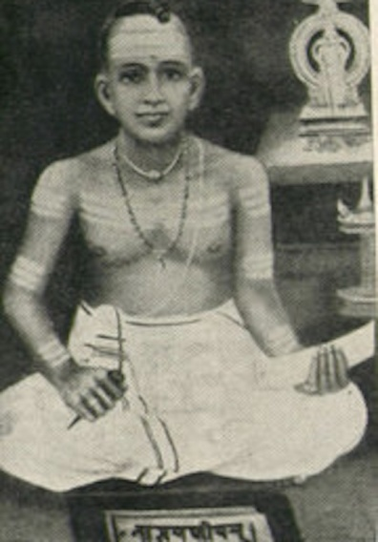

Bhatta Nārāyana Mrgarājalaksman, also known as Nishānārāyana, belonged to the Pancharatra Rarhi branch of Sandilya family of Brahmins. He was a Sanskrit scholar and writer who lived before 800 A.D. for he is cited by Vāmana in about 800 A.D. and by Ānandavardhana who refers to him more than once. He is believed to have been summoned from Kanyakubja to Bengal by King Ādisūra Ādityasena, the founder of the Sena Dynasty, who ruled before the Pāla Dynasty came to power in the middle of the eighth century, and who in 671 A.D. was a contemporary of Ādityasena, son of Madhavagupta, who ruled Kanyakubja.

**Early Life**

Nārāyana Bhaṭṭa, who is believed to have converted to Buddhism, was a disciple of Dharmakirti, which he co-authored Rupavatara. Dandin in his Avantisundarikatha Bhaṭṭa refers to Nārāyana as the author of three books, but which is more widely known as the author of Venisamhara, that dramatizes in six acts, some of the Mahabharata. The construction of this drama can be bad, but characteristic of energetic, a lot of dangerous situations, described in a long narrative digressions in poetry, but everyday style, but there are graces of poetry, power, crude and violent descriptions, impressive, sonorous diction, vivid image of certain scenes and situations, and vigorous characterization. The Tagore family claims its descent from the Bhatt Nārāyana.